**Thank you for ordering your**

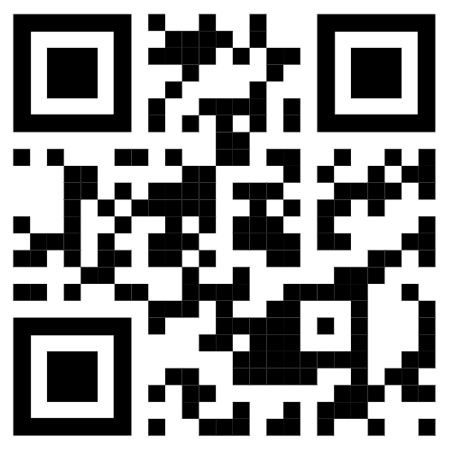

**bGeigieZen from Safecast.**

Prepared and packed by:

Name :Rob Oudendijk

Date :2024-11-22